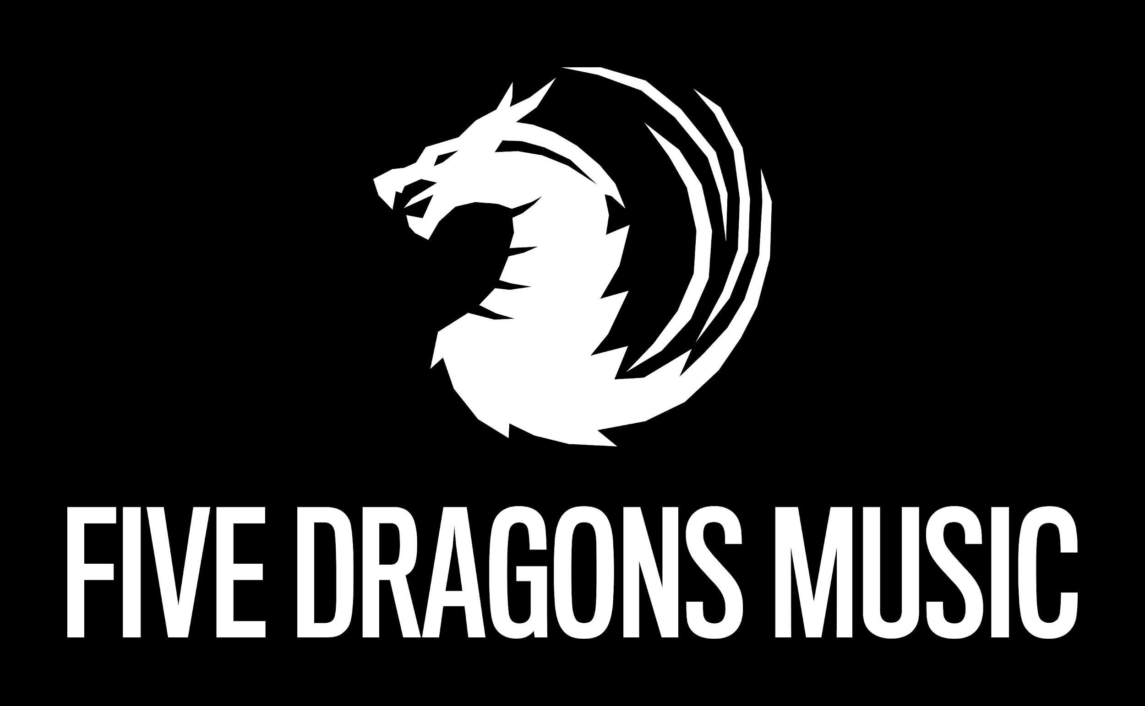

Terms of Use & Service for Music & Track Submissions
Effective September 10, 2020
These Terms of Use (the “TOU”) shall govern the use of the www.fivedragonsmusic and it’s applications on Windows Store, Apple App Store and Google Play. (“Five Dragons Music”) for music streaming, use of Music & Website Links, Purchase of digital music, Purchase of Merchandise, Clicking on third-party ads and/or general use and navigation of the website (together, the “Services”). By using the Services, you hereby agree to be bound by these TOU. The term “Customer” shall refer to any individual or entity, whether artist, agent or record label, who accepts these TOU by accesing the site, purchasing digital downloads, streaming music, purchasing merchandise, clicking on third party ads, and/or general use and navigation of the website.

ALL CUSTOMERS MUST COMPLY COMPLETELY WITH THESE TOU. IF YOU ARE AN INDIVIDUAL, YOU REPRESENT AND WARRANT THAT YOU ARE AT LEAST 18 YEARS OF AGE AS OF THE EFFECTIVE DATE OF THESE TOU.

Five Dragons Music acting as playlist curator is acting as a fan curated playlist. A submittee is hearby known as an individual, business or entity that submits music through or music submission portal. Submittees that press send on the Music Submission form accept all terms and conditions. No plays, services or actions are guaranteed by pressing submit button. No monetary payment is charged or received from submittees. Submittees are considered fans and supporting a fan curated playlist. Five Dragons Music website reserves the right to reject any submission and remove any tracks from playlists on streaming services and stores named but not limited to Spotify, Apple Music, ITunes, YouTube, Alphabet, LLC, Google Music, Deezer and Tidal.

Five Dragons Music has no affiliation with artists on the playlists that are curated. Nor with any associated record labels, management groups or other musical entities affiliated with sais artists.

Five Dragons Music reserves the right to keep submitted music for an indefinite amount of time on playlists on said music streaming platforms. Submittees that wish their music to be removed from playlists must submit via email, facebook, twitter, messenger or other social media a request to remove music. Five Dragons Music does not guarantee removal and will consider it only as a friendly courtesy to the submittee

Five Dragons Music, as a non-binding rule and courtesy will have submitted tracks on a playlist and will ask the submittee to respond to certain social media posts which include Twitter, Instagram Stories , YouTube Community Posts and Facebook Messages, Facebook Sories & Instagram Feeds. There is no binding requirement on either party. Five Dragons Music can remove music at anytime and response to social media posts do not guarantee placement on playlists.

Information submitted by submittes is subject to Five Dragons Music privacy policy. Please see privacy policy for further information.

